**UML Diagrams for problem statement 1 :**

USE CASE DIAGRAM:

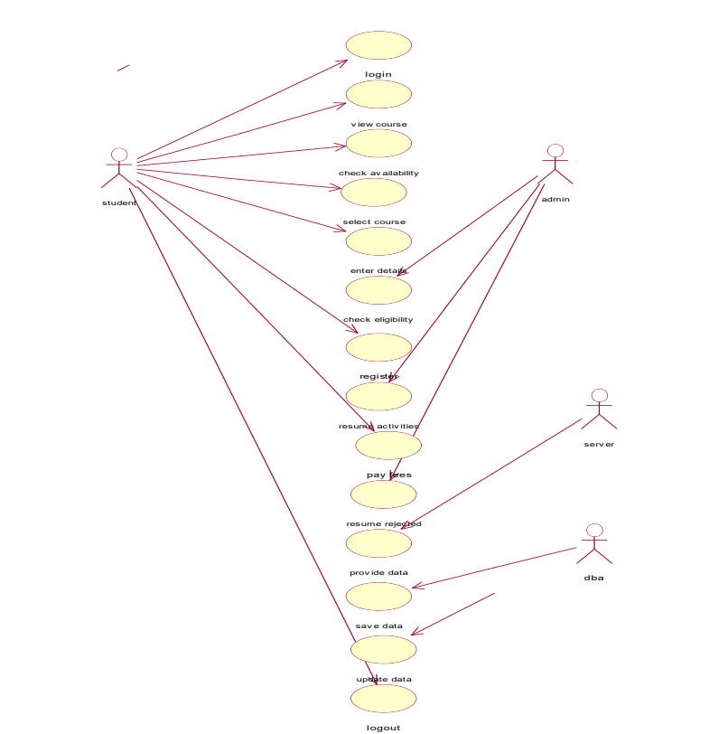

* The actors in the use case diagram are the course administrator and student.
* The use cases are to add a course, remove a course, courses, login, and register course.
* The actors use the use case are denoted by the arrow.
* The login use case checks the username and password for the student.
* The registration use case registers the student into the desired course after approval from the course administrator.
* The courses use case is used by the student to view all courses and by the course, administrator to update courses
* The add course use case is used by the course administrator to add new courses.
* The remove course use case is used by the course administrator to remove courses.

CLASS DIAGRAM:

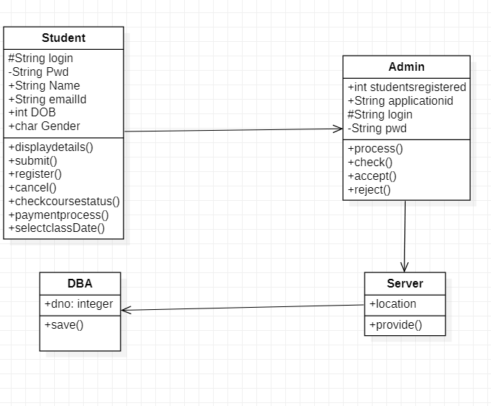

* USER-The user has attributes such as name and password and operations are login, give details, interesting courses, and logout. The applicant login and fill in the details that are required for registering for the course. After registration, the person can view the status of the course.
* THE DATABASE-The database has attributed such as name and operation is store. The purpose is to store the data.
* ADMINISTRATOR- The administrator has attribute such as name and operation are get details, verify details and accept the request for the course. The administrator gets the details from the database and verifies them with their database.

SEQUENCE DIAGRAM:

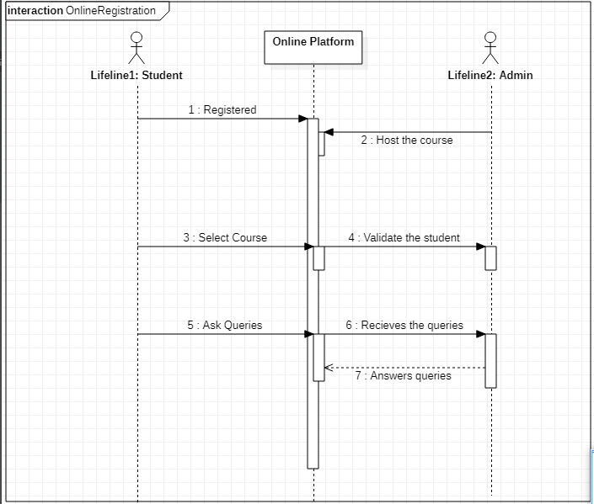

* Student

COLLABORATION DIAGRAM:

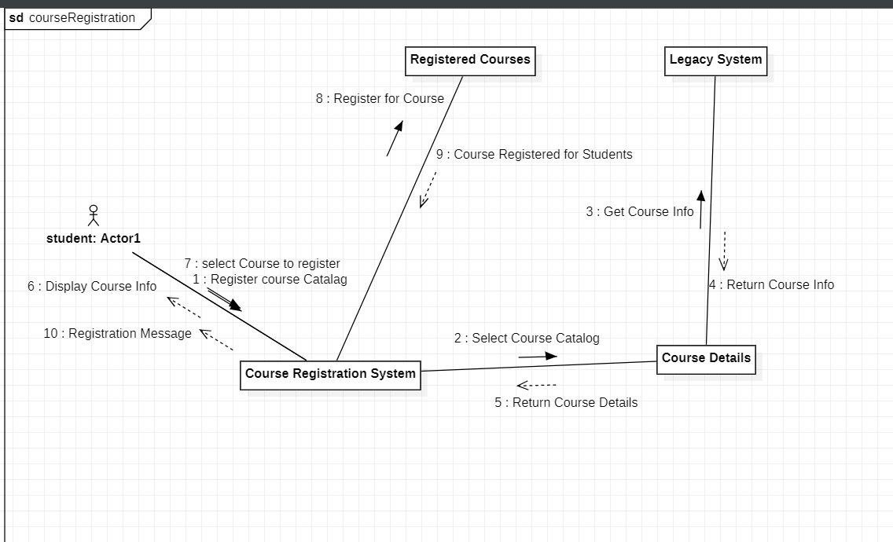

* The student will log in to the website and looks for the desired course.
* if the course he/she desired is available, he/she can check the details of that course and can proceed by submitting their application.

STATE CHART DIAGRAM:

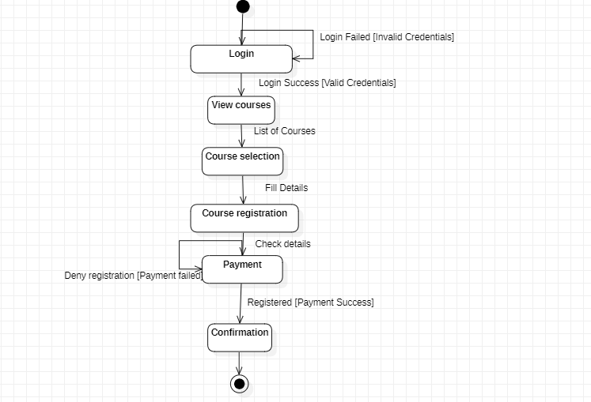

* The states of the Online Course Registration system are denoted in the statechart diagram.
* Login state represents authentication for logging into the site.
* View Courses state displays all the courses available. The student selects the course and registers for his/her interesting courses which are covered by Course selection and registration states respectively.
* In the payment details state, the payment for the particular course will be done and with that the registration completes.

ACTIVITY DIAGRAM:

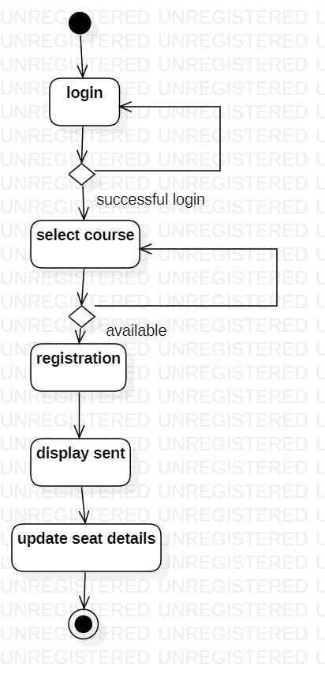

* The user login into the course registration system.
* He/she selects a particular course from the list of available courses.

* After the student register for the course, the institution starts the bill

operation and record are maintained.

COMPONENT DIAGRAM:

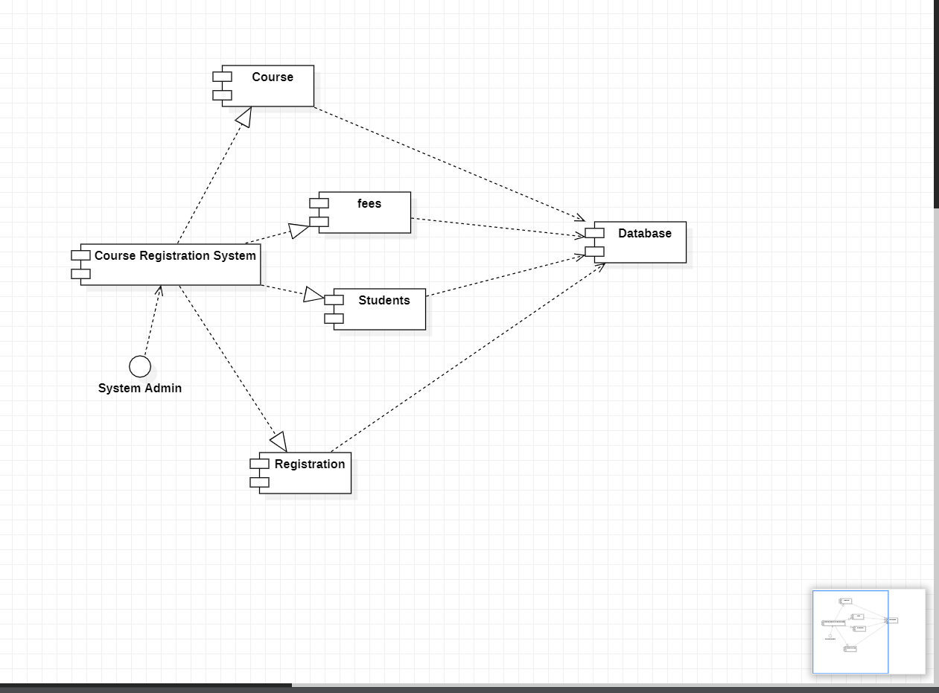

* The course registration system consists mainly of 4 components: Registration for the course, Paying up fees for registered courses, details of students who registered for a particular course, and Courses available.
* All the components are can get information from the database, ie they are connected to the database.